**📄 AutoPrintR Documentation**

**📘 Overview**

**AutoPrintR** is a lightweight Windows application that **automatically prints files** added to a specified folder. It monitors the folder in real time and sends printable files to the default printer without user intervention.

**🚀 Features**

* 🔍 Monitors a selected folder for new files
* 🖨️ Automatically prints PDF, Office, text, and image files
* 📋 Maintains a log of printed files to avoid duplicates
* 🛑 Prevents multiple instances from running simultaneously
* 🧾 Installs with a default installation timestamp
* 🖥️ Minimizes to system tray (if supported)

**🧰 Requirements**

* Windows 7 or later
* Default printer installed

**📦 Installation**

1. Run the installer
2. Check for the app on your Desktop and double click it to open it.
3. The app will launch and ask you to **choose a folder** to monitor.
4. AutoPrintR minimizes to the **system tray** (if supported). Right-click the tray icon to open or exit.

**📄 Supported File Types**

AutoPrintR automatically prints these file types:

|  |  |
| --- | --- |
| **File Type** | **Method Used** |
| PDF | SumatraPDF |
| DOC, DOCX | PowerShell Script + Office |
| XLS, XLSX | PowerShell Script + Office |
| PPT, PPTX | PowerShell Script + Office |
| TXT | Java Desktop Print |
| JPG, PNG, BMP | Java Image Print |

**🖱️ How to Use**

**Initial Setup**

1. Launch the application.
2. Choose a folder to monitor.
3. Drop files into the folder: printing will happen automatically.
4. View printed logs inside printed_files.txt.

**Changing Folder**

* Click **"Choose/Change Folder"** in the GUI.
* Select a new folder and confirm.

**System Tray (if available)**

* App minimizes to tray when closed.
* Right-click tray icon to **Show** or **Exit**.

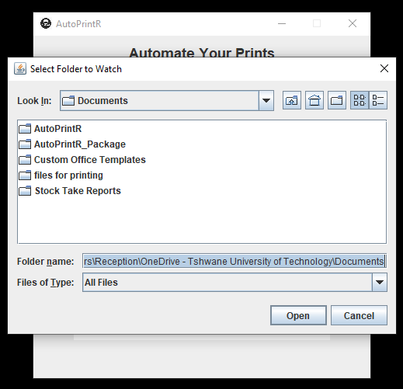

***Choose “watch folder”: which is the folder that has all the files to print or where future files should be pasted/moved/modified to be printed out.***

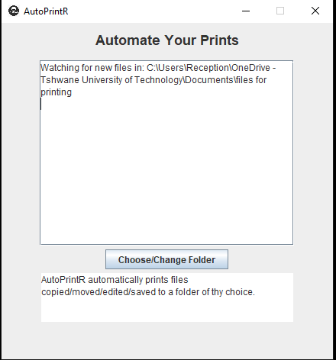***A message that the application is waiting for new files in the watch folder.***

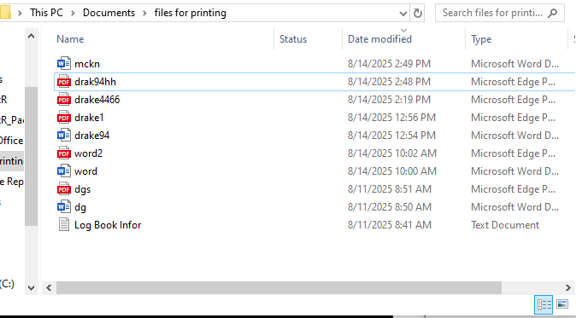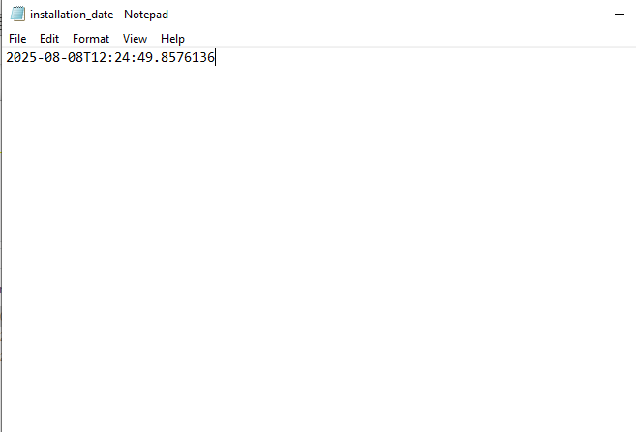***A new file called “drak94hh” has been pasted into the watch folder and will be printed.***

***As you can see the installation date is 08/08/25, 12:24 and the modification date of the file is 14/08/25 and our printer will start printing files modified/created after the installation date.***

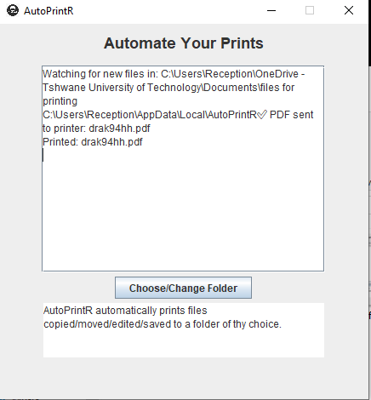***A message that the file: “drak94hh” has been printed.***

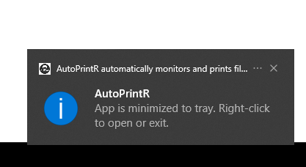

***When the application is closed, it gets minimized to the system tray where it is still active but in the background. To access the system tray, Click the arrow point (^) up located in your taskbar. There you will find the AutoPrintR app. This is done in order to actively print out files in the background as they are added to the watch folder without the user directly interacting with the app.***

***The arrow is pointing to the location of the system tray.***

**⚙️ Technical Details**

* Prevents multiple instances via a local port lock (port_number.txt)
* Uses Java WatchService API to detect new files
* Skips old files (based on installation timestamp)
* Keeps track of already printed files

**⚠️ Troubleshooting**

|  |  |
| --- | --- |
| **Problem** | **Solution** |
| App doesn't launch | Restart your machine and try launching it again |
| Files aren't printing | Check if your default printer is set and online |
| PDF not printing | Check if your default printer is set and online |
| Office files not printing | Confirm Microsoft Office is installed and PowerShell is enabled |
| App "disappears" after closing window | System Tray might not be supported; restart app manually |
| Tray icon not visible on Windows 7 | Modify Windows tray settings |

**🛑 Limitations**

* No support for multi-page print previews
* No UI feedback on printer errors
* System Tray required for full UX (auto-hide, tray menu)

**👨‍💻 Developer Notes**

* Written in Java 8+
* Uses Java AWT/Swing for UI and tray
* File monitoring via WatchService
* Office printing powered by PowerShell scripts
* Can be extended to support:
  + Multiple folders
  + Printer selection
  + Print settings customization

**📜 License**

AutoPrintR is a proprietary software product. Unauthorized reproduction, distribution, reverse-engineering, modification, or resale of this application is strictly prohibited and may result in legal action under applicable laws.

By installing and using AutoPrintR, you agree to the following terms:

* You may use this software for personal or internal business purposes only.
* You may not decompile, disassemble, or reverse-engineer any part of the software.
* Redistribution, either in original or modified form, is not allowed without explicit written permission from the developers.
* You may not use this software to offer commercial printing services unless granted a commercial license.

The developers of AutoPrintR are not responsible for any data loss, printing errors, or damages arising from the use or misuse of the application.

All rights reserved © 2025 Tshepo Mpofu & Vutlhari Maswanganyi

**📞 Contact / Support**

For issues, email: [***mpofuglen23@gmail.com***](mailto:mpofuglen23@gmail.com) or [***vutlhari23maswanganyi@gmail.com***](mailto:vutlhari23maswanganyi@gmail.com)  
Or visit: <https://github.com/Glen-Mpofu/AutoPrintR/issues>